MOBILE APPLICATION DEVELOPMENT PROPOSAL
AI-Powered Property Management and Services Platform
Table of Contents
1. Executive Summary 1
2. Project Objectives 1
3. Proposed Solution 1
3.1 Mobile Application 2
3.2 Administration Portal 2
3.3 Backend Platform 2
4. Functional Scope 3
4.1 User and Access Management 3
4.2 Property and Tenant Management 3
4.3 Maintenance Management 3
4.4 AI-Assisted Operations 4
4.5 Contractor and Service Marketplace 4
4.6 Field and Gig Worker Services 5
4.7 Inspection and Compliance 5
4.8 Financial Services 5
4.9 Notices and Legal Services 6
4.10 Communication 6
4.11 Documents and Media 6
4.12 Reporting and Dashboards 6
5. Proposed User Experience 7
6. Proposed Technical Approach 7
7. Proposed Delivery Methodology 8
8. Project Timeline 8
9. Proposed Project Phases 8
10. Key Project Deliverables 11
11. Project Governance 12
12. Client Responsibilities 13
13. Assumptions and Dependencies 13
14. Out of Scope 13
15. Change Management 14
16. Quality and Acceptance 14
17. Post-Launch Support 15
18. Conclusion 15

Executive Summary
We propose the design and development of an AI-powered Property Management and Services Platform that will provide a centralized digital ecosystem for managing property operations, tenants, maintenance, contractors, inspections, compliance, payments, communications, and related professional services.
The proposed solution will consist of:
- One role-based mobile application
- A web-based administration portal
- A centralized backend platform
- Integrated AI-assisted capabilities
- Contractor and service-provider marketplace capabilities
- Secure payment workflows
- Inspection and compliance management
- Reporting and operational dashboards
The platform will be designed to support multiple user roles within a unified ecosystem while providing each user with an appropriate and personalized experience based on their organization, permissions, and active role.
The proposed solution will be developed using a scalable and modular approach to support future growth, additional integrations, and expansion into consumer-facing services.

Project Objectives
The primary objectives of the project are to:
- Digitize and centralize property management operations.
- Improve communication between property stakeholders.
- Simplify maintenance reporting and resolution.
- Provide a structured marketplace for contractors and service providers.
- Improve visibility into inspections and compliance activities.
- Support controlled financial and payment workflows.
- Use AI to improve operational decision-making and efficiency.
- Provide role-specific user experiences through a single application.
- Create a scalable foundation for future platform expansion.
- Reduce manual processes and improve auditability.

Proposed Solution
The proposed solution will include the following primary components.

3.1 Mobile Application
A single mobile application will support multiple user roles:
- Tenant
- Landlord / Property Owner
- Property Manager
- Contractor
- Field Worker / Gig Worker
- Inspector
- Attorney
The application will dynamically provide:
- Role-specific dashboards
- Role-specific navigation
- Authorized functionality
- Organization switching
- Role switching
- Personalized notifications
A user with multiple roles will be able to select the appropriate role when accessing the application and switch between eligible roles during an active session.

3.2 Administration Portal
The administration portal will provide authorized platform administrators with capabilities to manage:
- Users
- Organizations
- Roles
- Permissions
- Marketplace participants
- Platform configuration
- Compliance configuration
- Disputes
- Feature settings
- Audit activities

3.3 Backend Platform
A centralized backend platform will manage:
- User identity
- Organization membership
- Authorization
- Business workflows
- Property data
- Maintenance operations
- Marketplace activities
- Payments
- Inspections
- Compliance
- Notifications
- Documents
- Audit history
- External integrations

Functional Scope

4.1 User and Access Management
The platform will support:
- Secure user registration and login
- Organization membership
- Multiple roles per user
- Permission-based access
- Active organization selection
- Role selection
- Role switching
- Secure session management

4.2 Property and Tenant Management
The platform will provide functionality for:
- Property management
- Unit management
- Tenant profiles
- Lease information
- Property assignments
- Tenant history
- Property documents
- Unit-level operational information

4.3 Maintenance Management
The platform will provide an end-to-end maintenance process.
The workflow will include:
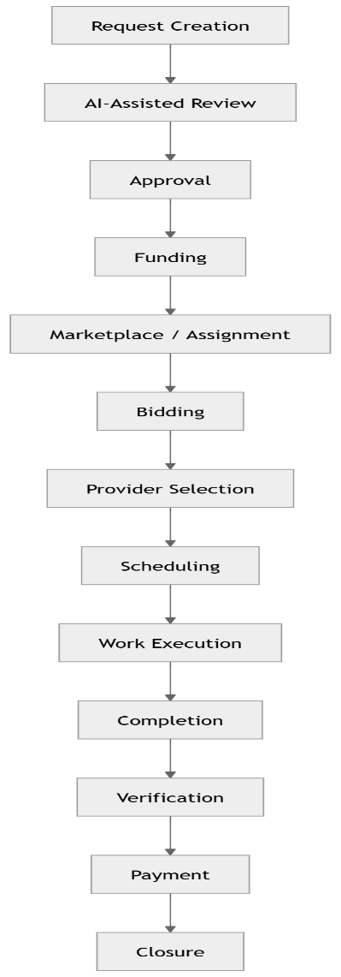
The workflow will also support dispute and cancellation scenarios.

4.4 AI-Assisted Operations
AI capabilities will support:
- Maintenance issue classification
- Image and media analysis
- Urgency recommendations
- Service-provider recommendations
- Bid analysis
- Operational summaries
- Inspection assistance
- Compliance assistance
- Predictive insights
AI functionality will operate as an assistance layer and will not independently execute sensitive financial, legal, or regulatory decisions.

4.5 Contractor and Service Marketplace
The platform will support:
- Service-provider onboarding
- Profile management
- Credentials
- Service areas
- Job opportunities
- Bid submission
- Bid comparison
- Provider selection
- Work assignments
- Performance history

4.6 Field and Gig Worker Services
The platform will support property-related assignments such as:
- Property visits
- Photography
- Inspections
- Verification
- Notice delivery
- Key handover
- Other approved field activities

4.7 Inspection and Compliance
The platform will provide:
- Inspection scheduling
- Checklists
- Findings
- Corrective actions
- Re-inspections
- Compliance requirements
- Deadline tracking
- Compliance reminders
- Supporting documentation

4.8 Financial Services
The proposed platform will support:
- Rent tracking
- Payment workflows
- Payment approval
- Payment release
- Transaction history
- Reconciliation
- Refund and dispute processes where applicable
Payment processing will be integrated with an approved third-party payment provider.

4.9 Notices and Legal Services
The platform will support:
- Notice creation
- Delivery tracking
- Proof of service
- Legal case records
- Attorney profiles
- Attorney selection
- Legal document management
- Case activity tracking

4.10 Communication
The platform will provide:
- Context-based messaging
- In-app notifications
- Push notifications
- Email notifications
- SMS notifications
- Communication history

4.11 Documents and Media
The system will support secure management of:
- Photos
- Videos
- Invoices
- Inspection reports
- Licenses
- Insurance documents
- Legal documents
- Compliance records
Documents will be associated with relevant platform activities.

4.12 Reporting and Dashboards
Role-based dashboards and reporting will provide visibility into:
- Properties
- Tenants
- Maintenance
- Marketplace activities
- Inspections
- Compliance
- Payments
- Operational performance

Proposed User Experience
The platform will be designed with the following user experience principles:
- Simple onboarding
- Minimal navigation complexity
- Role-based interfaces
- Fast access to frequently used functions
- Mobile-first workflows
- Clear status indicators
- Contextual actions
- Responsive design
- Consistent user interface patterns
- Accessible user interactions
The application will prioritize usability for users performing field work as well as users managing large portfolios.

Proposed Technical Approach
The solution will be developed using a modular and scalable architecture.
Mobile Application
- Flutter
- iOS and Android support
- Single codebase
- Role-based user experience
- Offline capability for selected operations
Backend
- API-driven architecture
- Modular business services
- Workflow management
- Centralized authorization
- Integration layer
Data Platform
- PostgreSQL
- Redis
- Object storage
- Queue-based background processing
- Search capabilities where required
AI
- AI provider integration
- Structured AI responses
- Authorization controls
- Human approval workflows
- AI activity tracking
Final technology selection will be confirmed during the technical design phase.

Proposed Delivery Methodology
The project will follow an iterative development methodology.
Each major phase will include:
This approach allows the client to review progress throughout the project rather than waiting until the entire system is completed.

Project Timeline
Estimated Overall Duration
Approximately 6-7 Months
The final duration will depend on:
- Final approved scope
- Number of integrations
- AI complexity
- Jurisdiction-specific compliance requirements
- Payment provider onboarding
- Client feedback and approval timelines

Proposed Project Phases
Phase 1 — Discovery and Planning
Duration: 1-3 Weeks
Activities:
- Review approved requirements
- Conduct stakeholder discussions
- Finalize functional scope
- Identify assumptions
- Define MVP priorities
- Prepare detailed user stories
- Define acceptance criteria
- Prepare delivery plan
Deliverables:
- Final FRD
- Product Scope
- Project Plan
- Acceptance Criteria
- Delivery Roadmap
Phase 2 — UX and UI Design
Duration: 4-6 Weeks
Activities:
- User journey design
- Information architecture
- Wireframes
- Role-specific flows
- High-fidelity UI design
- Design system
- Prototype review
Deliverables:
- User flows
- Wireframes
- UI/UX designs
- Interactive prototype
- Design system
Phase 3 — Platform Foundation
Duration: 7–9 Weeks
Development of:
- Authentication
- User profiles
- Organizations
- Roles and permissions
- Session management
- Core backend
- Database foundation
- Administration foundation
Phase 4 — Property and Core Operations
Duration: 10-13 Weeks
Development of:
- Property management
- Unit management
- Tenant management
- Lease information
- Document foundation
- Dashboard foundation
Phase 5 — Maintenance and Marketplace
Duration: 14–17 Weeks
Development of:
- Maintenance requests
- Workflow management
- Media uploads
- Contractor onboarding
- Marketplace
- Bidding
- Provider selection
- Job assignment
- Work execution
Phase 6 — Inspections, Compliance, and AI
Duration: 18–20 Weeks
Development of:
- Inspection management
- Checklists
- Findings
- Corrective actions
- Compliance tracking
- AI-assisted maintenance
- AI recommendations
- AI operational insights
Phase 7 — Financial, Notice, and Legal Workflows
Duration: 20–22 Weeks
Development of:
- Rent tracking
- Payment workflows
- Payment provider integration
- Notice management
- Legal case management
- Attorney marketplace
- Dispute management
Phase 8 — Communication and Analytics
Duration: 23–25 Weeks
Development of:
- Messaging
- Notifications
- Reporting
- Analytics
- Performance dashboards
Phase 9 — Testing and Production Readiness
Duration: 26–28 Weeks
Activities:
- Functional testing
- Integration testing
- Security testing
- Performance testing
- User acceptance testing
- Bug fixing
- Production configuration
- Deployment preparation

Key Project Deliverables
The project will produce:
Documentation
- Functional Requirements Document
- Technical Architecture Document
- API specifications
- Data model documentation
- Integration specifications
- Test documentation
- Deployment documentation
Design
- UX strategy
- User flows
- Wireframes
- UI designs
- Design system
Software
- Flutter mobile application
- Backend services
- Administration portal
- Database implementation
- Integration components
- AI integration
- Notification services
Quality
- Test cases
- Test reports
- Security testing
- Performance testing
- User acceptance testing support

Project Governance
The project should include regular communication between the development team and the client.
Recommended meetings:
Meeting | Frequency
Project Status Meeting | Weekly
Sprint Planning | Every 2 Weeks
Sprint Demonstration | Every 2 Weeks
Design Review | As Required
Architecture Review | Monthly
Management Review | Monthly
Key decisions and approvals will be documented throughout the project.

Client Responsibilities
The client will be expected to provide:
- Timely requirement clarification
- Business process information
- Design feedback
- Required compliance information
- Third-party integration accounts
- Payment provider information
- AI provider preferences, if applicable
- Test users
- User acceptance testing participation
- Timely approvals
Delays in approvals or third-party onboarding may affect the project timeline.

Assumptions and Dependencies
Project delivery depends on:
- Final client approval of scope
- Availability of stakeholders
- Timely feedback
- Third-party provider availability
- Payment provider onboarding
- KYC/KYB requirements
- Jurisdiction-specific regulatory requirements
- AI provider availability
- Maps and messaging provider integration
- App Store and Play Store approval processes
Changes in these areas may require adjustments to scope, cost, or timeline.

Out of Scope
Unless specifically included in the approved commercial agreement, the following will require separate evaluation:
- New functionality not included in the approved FRD
- Significant changes to approved workflows
- New third-party integrations
- Jurisdiction-specific legal implementation not previously identified
- Custom AI model training
- Hardware or IoT development
- Extensive data migration
- Consumer Phase 2 implementation

Change Management
Any change requested after scope approval will follow a structured process:
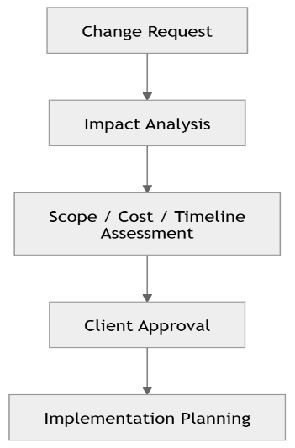
Changes will be implemented only after approval of the applicable impact.

Quality and Acceptance
The solution will be evaluated against approved requirements.
Key quality activities will include:
- Functional testing
- Integration testing
- Regression testing
- Security testing
- Performance testing
- User acceptance testing
A feature will be considered complete after:
- Development completion
- Internal testing
- Acceptance criteria validation
- Client review where applicable
- Resolution of agreed critical issues

Post-Launch Support
A post-production support period may include:
- Production monitoring
- Critical issue resolution
- Bug fixes
- Performance monitoring
- Technical support
A separate maintenance and support agreement can define:
- Support duration
- Response times
- Service levels
- Monitoring
- Enhancements
- Release schedules

Conclusion
The proposed platform will provide a scalable foundation for modern property management and service delivery.
By combining role-based access, centralized property operations, structured maintenance workflows, AI-assisted recommendations, marketplace capabilities, inspections, compliance, payments, and communication, the platform can provide an integrated ecosystem for multiple stakeholders.
The proposed phased delivery approach will allow the project to prioritize core business value while maintaining flexibility for future expansion.
We look forward to working closely with the client to refine the final scope and deliver a secure, scalable, high-performance, and user-friendly platform.

